15693 Demo User Manual

Manual Name：15693 Demo User Manual
Manual NO ：
Version：V1.0

Total 7 pages
(Including cover)

Compose ZhangYong
Review
Countersign

Cilico Microelectronics Co., Ltd
Modifiy record
File No. | Version | Composed By / Modified By | Compose / Modify Date | Modify Reason | Major changes  （Write main Points） | Review By
 | V1.0 | ZhangYong | 2017.03.27 | None | None | ShiLiangYi
Note: When the file is prepared for the first time, write “None” on "Modify Reason" and "Major modifications columns.

Contents

1. Purpose 4
2. Applicable Scope 4
3. Install APK 4
4. open NFC Service 4
5. Launcher App 4
6. Card Discover 5
7. Card Information 5
8. Card manager 5
8.1 read 5
8.2 write 6
8.3 lock 7
9. Help 8

1 Purpose
Guide how to identify 15693 card, how to read the card data, how to write data to the card, and how to lock card.
2 Applicable scope
Use for the IOT handheld terminals which supports the NFC-enabled .
3 Install APK
First ensure that the device supports the NFC function, Then check whether the device had install this APP, if it was not installed，so install NfcManager.apk。
4 Open NFC Service
First open the “Setting” App ，Then select “more”options of “Wireless & networks”group,，Last select “NFC”options，and open NFC service，and open “Tag reading & writing”。
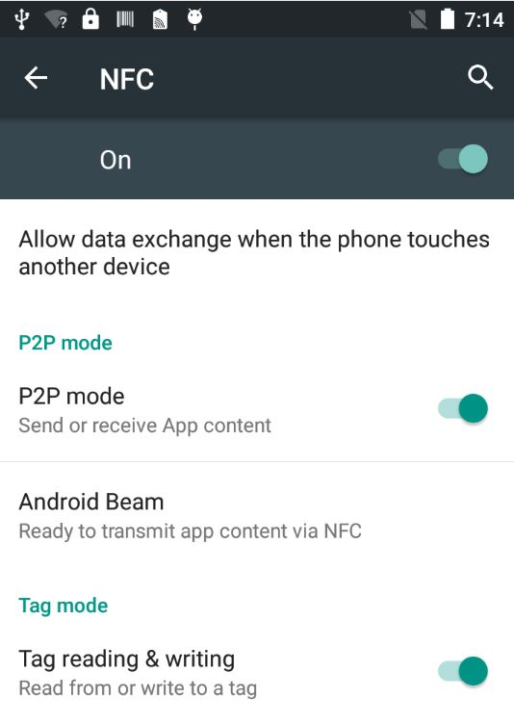

5 Launcher APP
Click the NFC APP Icon to launcher it. 
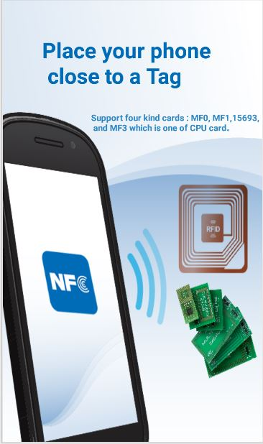
6 Card Discover
Put the 15693 type card into the back of the handheld terminal. After hearing the sound of "toot" , the application interface will automatically pop up, so keep the card not to be moved。
7 Card Infomation
After the card is successfully identified, the basic information of card is parsed and displayed in the top area
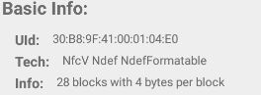
8 Card Manager
8.1 Read
8.1.1 Read single Block
First select the block No.(default as 0), Then click the "read" button, Last the results will be displayed in the bottom of the information area.
8.1.2 Read multiple blocks
First select the starting block No. (default as 0), then select the count of blocks which need to read, Last click the "read" button, the results will be displayed in the bottom information area.
8.1.3 Read the storage format flag
Click the "Read" button, the results will be displayed in the bottom information area.
8.1.4 Read the application area
Click the "Read" button, the results will be displayed in the bottom information area.
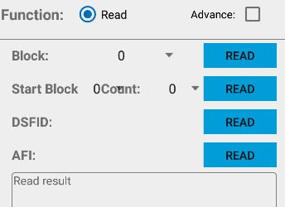
8.2 Write
8.2.1 Show Write Function
First select the "Advanced ", then select "write" radio button, and you can see the interface of write function
8.2.2 Write One Block
First select the No. of the block which to be written (default as 0), then input the four bytes hex data, and finally click the "write" button, the result of success or failure will be shown.
8.2.3 Write DSFID
First input a byte hex data, Then click "write" button, Last the result success or failure will be shown below.
8.2.4 Write AFI
First input a byte hex data, Then click "write" button, Last the result success or failure will be shown below.
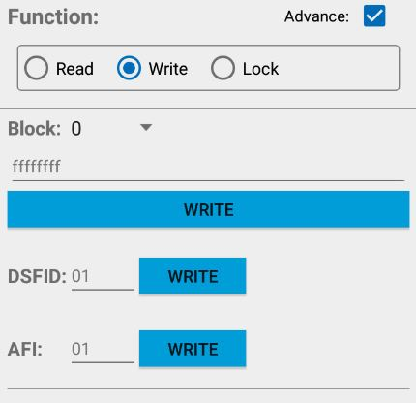
8.3 Lock
8.3.1 Show Lock Function
First select the "Advanced ", then select "lock" radio button, and you can see the interface of write function
8.3.2 Lock block
Click the first line "lock" button,and once lock successful, the storage format flag can not be modified
8.3.3 Lock DSFID
Click the second line "lock" button,and once lock successful, the DSFID can not be modified
8.3.4 Lock AFI
Click the third line "lock" button,and once lock successful, the AFI can not be modified
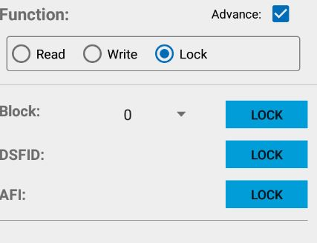
9 Help
Click the upper right corner of the icon, enter the help interface, which describes the 15693 card basic information, as well as some operating instructions.

